Classification of Tyrosine Samples Based on Random Forest and Neural Networks

Gabe Henderson
College of Charleston
9756 NW Caxton Ln
Portland, OR, 97229
971-678-5104
hendersongj@g.cofc.edu

ABSTRACT
The effect of different data mining techniques was applied to three data sets of Tyrosine samples. The purpose was to try and create a classifier that could accurately predict the presence of Tyrosine in a given sample. Random forest and neural networks were applied to the problem, both separately and together to try and get the most accurate prediction capability.
General Terms
Data Mining, Random Forest, Neural Networks
Keywords
Classifier, NNET, randomForest, R language, Carat

INTRODUCTION
Random forest is a data mining technique that utilizes classification trees. A random forest grows a host of classification trees, and these tree’s then vote on any input vector that is passed to them. Random forests have several features that are advantageous, including their ability to handle thousands of input variables, as well as their ability to estimate what variables are important in the classification. They also don’t have to worry about over fitting the data set.
Neural networks are a data mining technique that are inspired by the way that biological nervous systems process information. They do this by having a number of neurons, which work in unison to classify an input vector. Each of the neurons is assigned a specific weight, which is changed during the training phase. Neural networks are highly customizable, and the number of neurons used, the number of hidden layers, and the learning rate can all be adapted and changed. Neural networks offer a few key advantages, such as their ability to adaptively learn and extract patterns and detect trends that are far too complex for humans, or other machine learning techniques to pick up.
The purpose of this paper was to examine these two machine learning techniques. Random forest are excellent classifiers, but to help detect complex trends a neural network was introduced as well. A random forest, a neural network that utilized the random forest to determine variable importance, and a plain neural network were all compared on accuracy over the three data sets. The neural network utilizing the random forest should have the best accuracy on the validation set over all three data sets, because it combines the benefits of both techniques; the simplicity and variable selection capabilities of the random forest, and the complexity and trend recognition capabilities from the neural network.

METHODS
This program made extended use of R packages. The packages utilized were Caret, nnet, randomForest, and e1071. Caret allowed for tuning of training parameters on the neural network, and e1071 was utilized so that a confusion matrix could be generated.
Three data sets were given, Tyrosine10, Tyrosine5, and Tyrosine2. These data sets had different difficulties, with Tyrosine10 being the easiest and Tyrosine2 being the most difficult because the data contained the most noise. Each data set contained 1095 variables, and 1034 samples. 800 samples were utilized for testing, and 233 were used as a validation set.
The Random forest used was built using the randomForest package. It utilized 201 trees to reach its decision; an odd number so that ties could be broken. From the Random forest that was generated, the importance of each variable was determined by %IncMSE. %IncMSE is the error rate for classification minus the error rate of classification after permuting each predictor variable, averaged over all trees and normalized by the standard deviation of the differences. This allowed each variable to be ranked accordingly from most important to least.
The first neural network utilized the top 150 variables as neurons. This neural network was built using the nnet package, combined with Carat. Carat allowed for the optimization of the neural network. Neural networks with a hidden layer of 1, 5, and 10 neurons in the hidden layer were used, as well as decay of .01, .1, and 1. Carat then selected the most accurate model to use, based on RMSE (random mean squared error) values.
The second neural network utilized all of the variables. It followed the same process as above, with variation of neurons in the hidden layer of 1, 5, and 10, and decay rates of .1 and .25.
For each of the data mining techniques, a confusion matrix was generated based on each models results when run on the validation set. This told the overall accuracy, as well as the accuracy on positive and negative samples for each technique. These are the values that were compared between techniques.

RESULTS
After building each model on a training set, this is the accuracy, sensitivity, and specificity over each of the three tyrosine data sets. A random validation set was created from each .CSV, and the model run on that set.
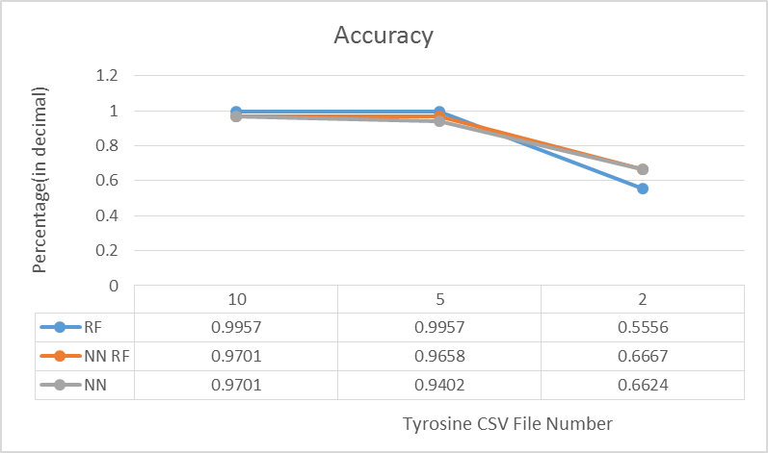
Figure 1: Graph of accuracy over the varying CSV Tyrosine files
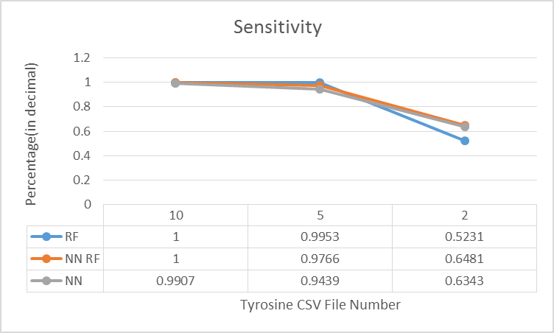
Figure 2: Graph of sensitivity over the varying CSV Tyrosine files
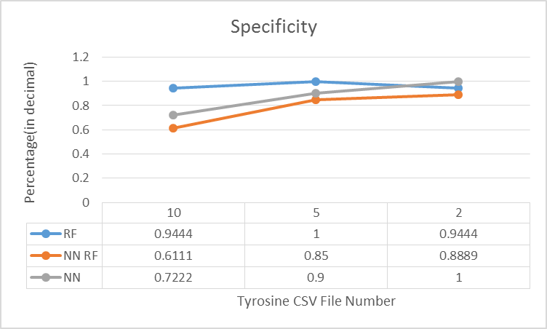
Figure 3: Graph of specificity over the varying CSV Tyrosine files

Examining the data, the best accuracy came from the random forest model on the first data set (the easiest), with an accuracy of 99.57%. However, by the last data set the neural networks were more accurate, with an accuracy of 66.67% for the neural network utilizing the random forest for variable selection, and 66.24% for the neural network by itself.
Using Carat, the neural network used in the neural network utilizing random forest had a hidden layer with a size of 10, and a decay (learning rate) of .01. This network was selected because it had a RMSE of .2116. The neural network selected for the plain neural network had a hidden layer with a size of 5, and a decay rate of .25. It was selected because it had a RMSE of .1344.

Discussion
The results did not bear out the hypothesis that the random forest would increase the accuracy of the neural network. The neural network, random forest, and the neural network and random forest all had similar accuracies on the easiest data set, as well as the second easiest data set. However, on the most difficult data set the neural network and the neural network with random forest both outperformed the random forest alone. This makes sense, as neural networks are supposed to excel in these types of situations. Unfortunately, the two neural networks had basically equivalent accuracies (.667 for the neural network with random forest and .6624 for the neural network). Accordingly, the random forest really didn’t help with the accuracy of the neural network.
The random forest did speed up the process of creating the model however. It took significantly longer to build the model without using the random forest, because of the sheer amount of variables. And the two neural networks had similar accuracies. This is encouraging because it showed that the random forest was successful at selecting variables that were significant.

Conclusion
The purpose of this paper was to examine two machine learning techniques, random forest and neural networks. Random Forest are excellent classifiers, but to help detect complex trends a neural network was introduced as well. It was hypothesized that the combined random forest and neural network would offer the most accurate technique for classifying Tyrosine samples.
However, there was no significant difference between the neural network that utilized the random forest and the one that didn’t. They had accuracy’s on the most difficult Tyrosine sample set of 66.67% and 66.34% respectively. However, the random forest did speed up the process of creating the model significantly, which would be useful in even larger data samples were creating a neural network from all the data wouldn’t be feasible.
There were many sources of possible error, as well as setbacks during this study. One problem with the neural network that ran on its own was the sheer amount of variables; ideally for any data mining technique, a there are significantly less variables than samples. Unfortunately that wasn’t the case this time. There was also trouble using the neural networks; often they would simply return entirely 0 values, which made it impossible to compute a confusion matrix, because there were no positive values. In addition, the more variables and hidden layers that were utilized, the longer it took for the model to generate which wasn’t ideal. The plain neural network model couldn’t even be tested using a hidden layer of size 10, because it created too many weights, and overrode the weight limit.
If this study was to be repeated, the researcher would examine other ways to narrow down the number of variables, and to find the most important variables. One promising method would be PCA, as it is ideally suited for the task. In addition, a possible future comparison could be to see just how many variables the neural network could be limited down to. Instead of using the top 150 most important variables, how few variables could the neural network use before it saw a drastic decrease in prediction accuracy?

REFERENCES
- Breiman L., Cutler A. Random Forests. Berkeley. https://www.stat.berkeley.edu/~breiman/RandomForests/cc_home.htm
- Stergious C., Siganos, D. Neural Networks. Imperial College London http://www.doc.ic.ac.uk/~nd/surprise_96/journal/vol4/cs11/report.html

- Breiman L., Cutler A. Random Forests. Berkeley. https://www.stat.berkeley.edu/~breiman/RandomForests/cc_home.htm
- Breiman L., Cutler A. Random Forests. Berkeley. https://www.stat.berkeley.edu/~breiman/RandomForests/cc_home.htm
[3] Stergious C., Siganos, D. Neural Networks. Imperial College London http://www.doc.ic.ac.uk/~nd/surprise_96/journal/vol4/cs11/report.html

